Modified Euler’s Series.
Q. Write a program in python to demonstrate Modified Euler’s Method. Aim: To write a program in python to demonstrate Modified Euler’s Method. Program:
def f(x, y):

return x + y # Example: dy/dx = x + y

main program
if name == "main":

x0 = 0.0 # initial x y0 = 1.0 # initial y h = 0.1 # step size
n = 5 # number of steps

print("="*70)
print(f"{'Modified Euler’s Method Approximation':^70}")
print("="*70) print(f"{'x':>8} {'y':>15}")

for i in range(n): k1 = f(x0, y0)
y_predict = y0 + h * k1 # Euler prediction
k2 = f(x0 + h, y_predict) # Corrector slope y1 = y0 + (h / 2) * (k1 + k2) # Improved estimate
print(f"{x0:8.4f} {y0:15.6f}") x0 += h
y0 = y1

print(f"\nApproximate value of y({x0:.1f}) = {y0:.6f}")

Output:

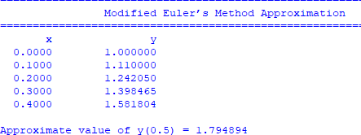

Conclusion: The above program has been executed successfully.

